**ASSIGNMENT-4**

| DATE | 01 November 2022 |
| --- | --- |
| Team ID | PNT2022TMID49588 |
| Project Name | Project-Personal Expense Tracker |
| Team Member Name | Remy Martha M(Team Leader) |

1. Write a python program to test a given number is prime or not

Program

n=int(input("enter the number"))

if n > 1:

for i in range(2, n):

if (n % i) == 0:

print(n, "is not a prime number")

break

else:

print(n, "is a prime number")

else:

print(n, "is not a prime number")

OUTPUT:

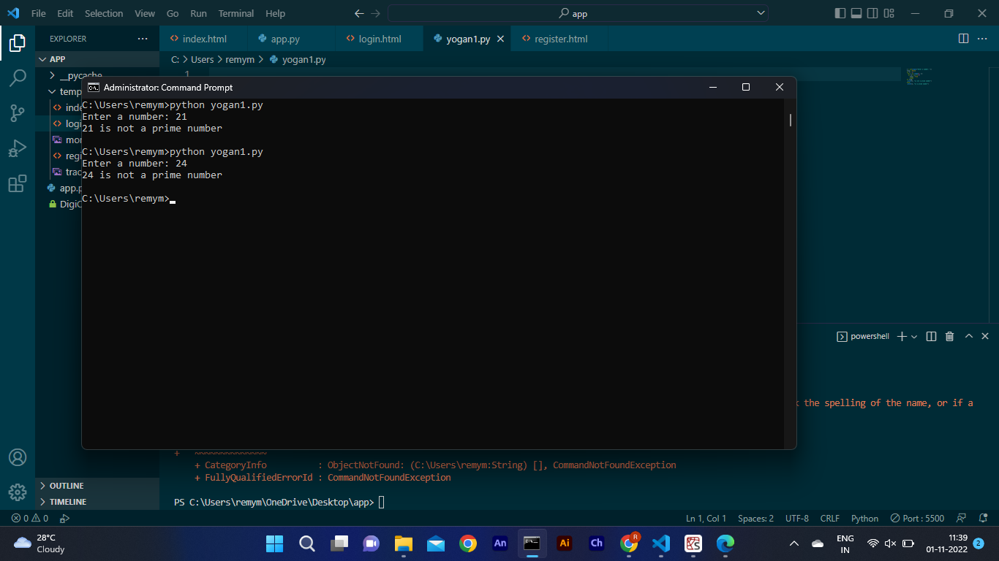

2.Write a python program to display prime number series up to given number

Program:

first=int(input("enter the 1st number"))

last=int(input("enter the last number"))

for n in range(first,last + 1):

if n > 1:

for i in range(2,n):

if (n % i) == 0:

break

else:

print(n)

OUTPUT:

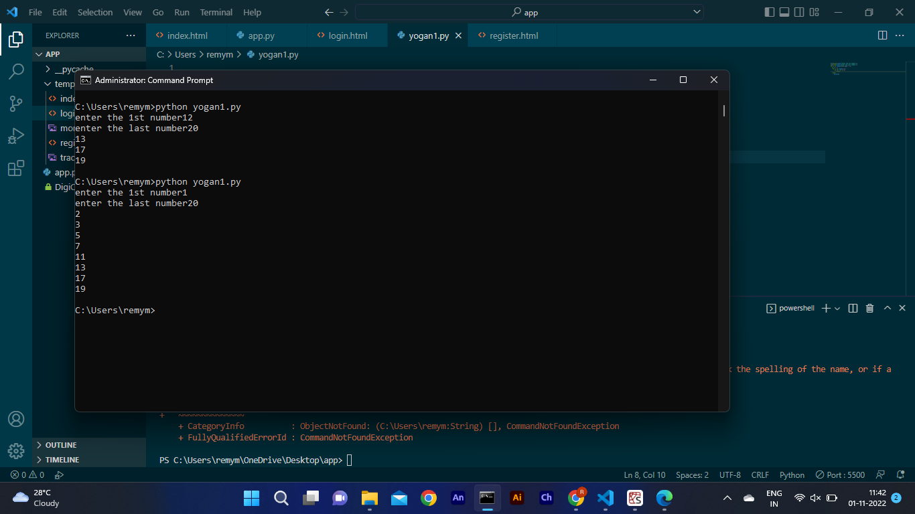

3.Write a python program to generate fibonacci series

Program:

n = int(input("How many times ? "))

a1, a2 = 0, 1

count = 0

if n <= 0:

print("Please enter a positive integer")

elif n == 1:

print("Fibonacci sequence upto",n,":")

print(a1)

else:

print("Fibonacci sequence:")

while count < n:

print(a1)

a = a1 + a2

a1 = a2

a2 = a

count += 1

OUTPUT:

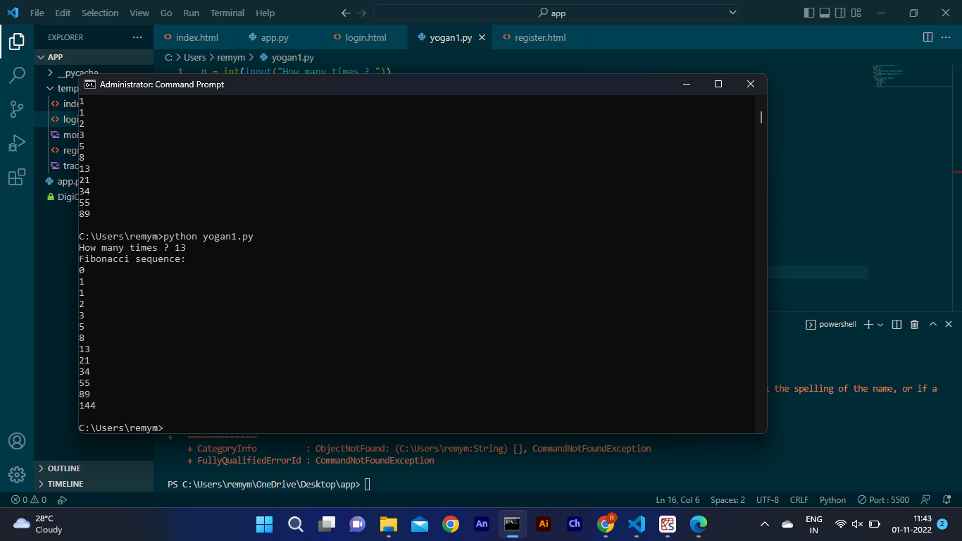

4.Write a program to generate odd numbers from m to n using while loop.

Program:

m=int(input("enter the 1st number"))

n=int(input("enter the last number"))

p=m

while (p<=n):

if(n%2!=0):

print(n)

p+=1

OUTPUT:

